## **Screencast-o-matic**

[Screencast-o-matic](https://screencast-o-matic.com/screen-recorder) is a free, web-based screencasting tool that will let you record and download a simple video of your screen, webcam and narration. You do not need to pay for the premium version.

1. Open up your presentation in Powerpoint (or whatever tool you have used to make your presentation).
2. Go to <https://screencast-o-matic.com/screen-recorder> and tap or click the button that says “Launch free Recorder”

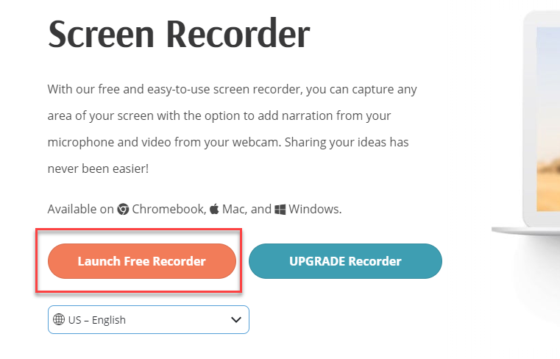

1. The free recorder app will then download. Once the download is complete, open the app.

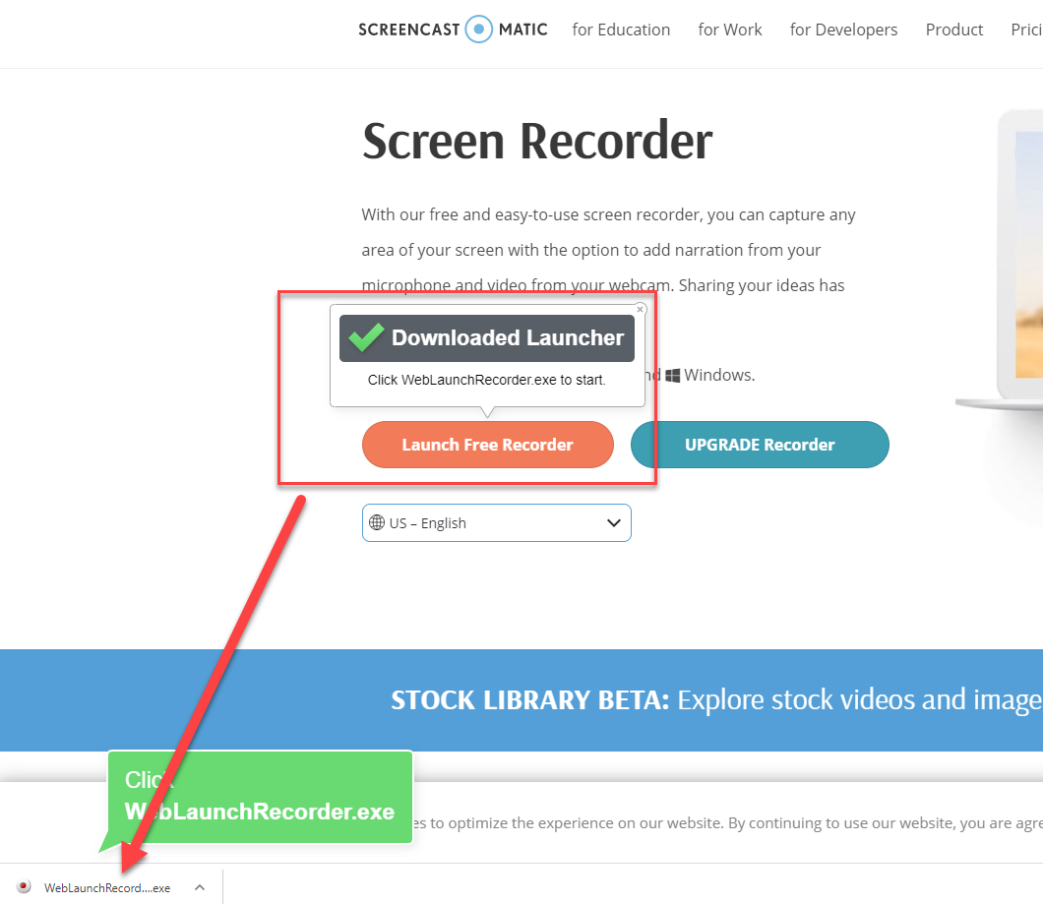

1. Resize the window on your screen as appropriate, select whether you want to record the screen or screen and webcam (webcam only is not recommended for a presentation) and check your microphone settings for narration (you should be able to see the green bar go up and down as you speak).

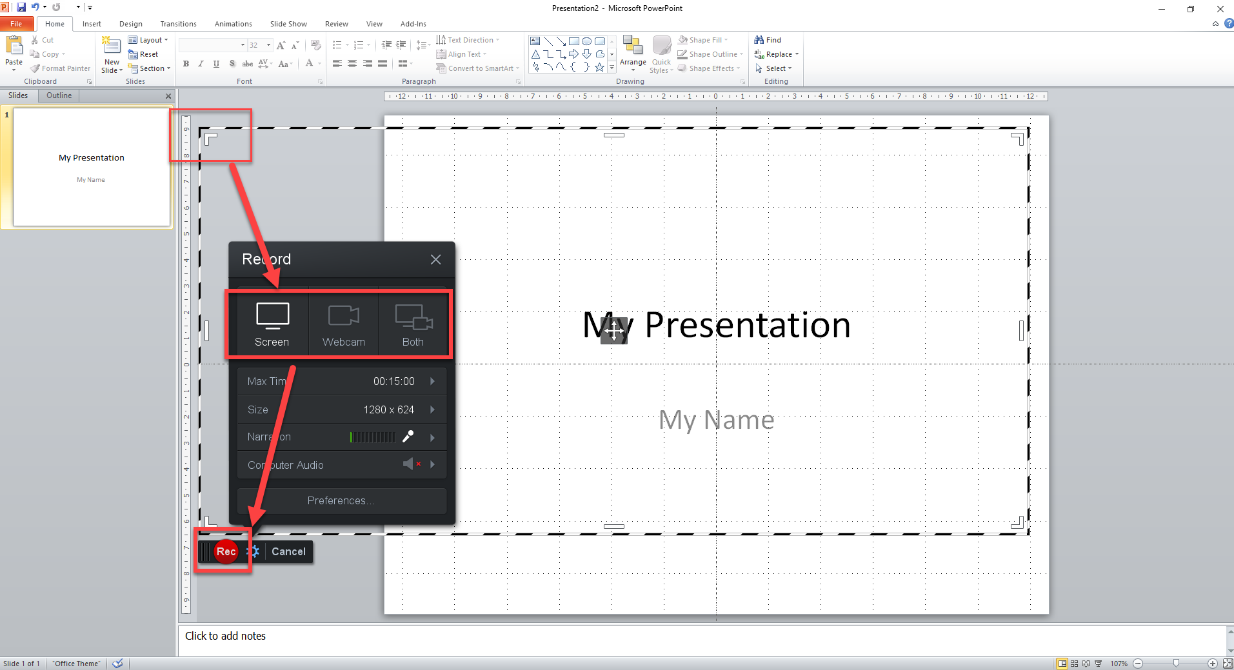

1. When you are ready, click or tap the “Record” button. You will see a countdown appear to the recording starting. This should be long enough to click or tap the “slideshow” button on powerpoint and begin your presentation.
2. When you have finished your recording, click or tap the “Pause” button.

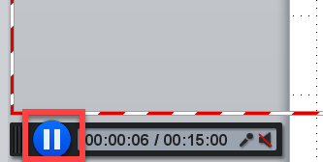

1. You can restart your recording by clicking or tapping “Rec” again, or click or tap “Done” to finalise the recording.

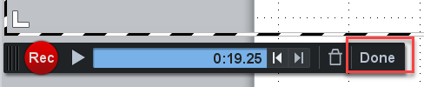

1. Select “Save/Upload” and then choose to “Save as a Video File”.

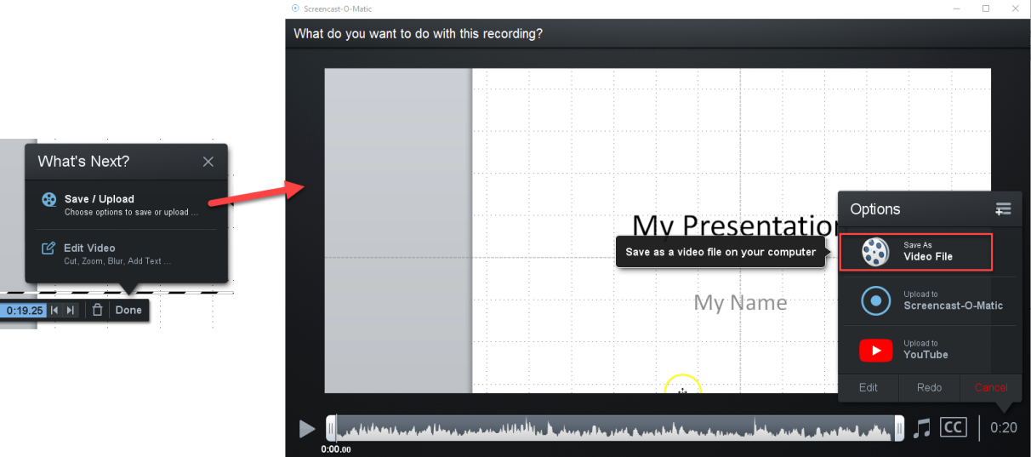

1. Your video will then be downloaded.

# Apple Devices

If you have an iOS11 or later apple device (or an iPadiOS), you can record your screen and audio by following the steps below:

1. Go to Settings > Control Centre > Customise Controls, then tap https://support.apple.com/library/content/dam/edam/applecare/images/en_US/il/ios13-add-icon.png next to Screen Recording.
2. Swipe up from the bottom edge of any screen. On iPhone X or later or iPad with iOS 12 or later, or iPadOS, swipe down from the upper-right corner of the screen.
3. Press deeply on grey record icon and tap Microphone.
4. Tap Start Recording, then wait for the three-second countdown.
5. Open Control Centre and tap red record icon. Or tap the red status bar at the top of your screen and tap Stop.
6. Go to the Photos app and select your screen recording.